**A PRELIMINARY PROJECT REPORT**

**ON**

**“Human Activity Identification”**

Submitted to

SAVITRIBAI PHULE PUNE UNIVERSITY

in completion of

PARTIAL FULFILLMENT OF THE REQUIREMENTS OF

**(B.E Computer Engineering)**

**BY**

Neha Marne B150234313

Akansha Jagtap B150234277

Isshita Paliwal` B150234272



Department of Computer Engineering

Sinhgad College of Engineering, Pune-41

**Accredited by NAAC with grade ‘A’**

**YEAR 2021-22**

# CERTIFICATE



Sinhgad Technical Education Society,

Department of Computer Engineering

Sinhgad College of Engineering, Pune-41

**Accredited by NAAC with grade ‘A’**

**“Human Activity Identification”**

Submitted to

SAVITRIBAI PHULE PUNE UNIVERSITY

in completion of

PARTIAL FULFILLMENT OF THE REQUIREMENTS OF

**(B.E Computer Engineering)**

BY

Neha Marne B150234313

Akansha Jagtap B150234277

Isshita Paliwal B150234272

Prof. M. P. Wankhade Prof. M. P. Wankhade

Internal Guide Head of Dept.

Department of Computer Engineering Department of Computer Engineering

Dr. S.D. Lokhande

Principal

SCOE, Pune

# ACKNOWLEDGEMENT

Every orientation works has an imprint of many people and it becomes our duty to express deep gratitude for the same.

During the entire duration of preparation for this Dissertation, we received endless help from a number of people and feel that this report would be incomplete if we do not convey graceful thanks to them. This acknowledgement is a humble attempt to thanks all those who were involved in the project work and were of immense help to us.

First and foremost we take the opportunity to extend our deep heartfelt gratitude to our guide and **Head of Department of Computer Engineering SCOE, Pune** **Prof M. P. Wankhade** for guiding us throughout the entire project and for her kind and valuable suggestions, without which this idea won’t have executed. We also humbly thank for his indispensable support, his priceless suggestions and for his valuable time.

# ABSTRACT

Human activity recognition plays a significant role in human-to- human interaction and interpersonal relations. The human ability to recognize another person’s activities is one of the main subjects of study of the scientific areas of computer vision and machine learning. With the advent of Pose estimation, which can be used on images/video input, it is now possible to collect and store data on different aspects of human movement under the conditions of free living. This technology has the potential to be used in automated activity profiling systems which produce a continuous record of activity pat terns over extended periods of time. Such activity profiling systems are dependent on classification algorithms which can effectively interpret motion data and identify different activities. This report reviews the different techniques which have been used to classify normal activities and/or identify falls from body-joints data. The report is structured according to the different analytical techniques and illustrates the variety of approaches which have previously been applied in this field. Although significant progress has been made in this important area, there is still significant scope for further work, particularly in the application of advanced classification techniques to problems involving many different activities.

# LIST OF FIGURES

|  |  |  |
| --- | --- | --- |
| **Sr. No** | **Name** | **Page No** |
| 1 | System architecture diagram | 9 |
| 2 | Use case diagram | 10 |
| 3 | Class Diagram | 11 |
| 3 | Activity diagram | 12 |
| 4 | Sequence Diagram | 13 |
| 5 | Data Flow Diagram | 14 |

# 

# INDEX

CERTIFICATE II

ACKNOWLEDGEMENT III

ABSTRACT IV

LIST OF FIGURES V

INDEX VI

1. INTRODUCTION 1

1.1 OVERVIEW 1

1.2 PROBLEM STATEMENT: 1

1.3 SCOPE STATEMENT: 1

1.4 MOTIVATION: 1

1.5 OBJECTIVE 2

1.6 PROPOSED SYSTEM 2

Pose Estimation 2

2. LITERATURE SURVEY 4

2.1 STUDY OF RESEARCH PAPERS 4

3. PROJECT PLANNING AND MANAGEMENT 6

3.1 SOFTWARE AND HARDWARE REQUIRENMENTS: 6

3.2 NON FUNCTIONAL REQUIREMENT: 7

3.3 PROCESS MODEL: 8

4. SYSTEM ANALYSIS & DESIGN 9

4.1 SYSTEM ARCHITECTURE: 9

4.2 USE CASE DIAGRAM: 10

4.3 CLASS DIAGRAM: 11

4.4 ACTIVITY DIAGRAM: 12

4.5 SEQUENCE DIAGRAM: 13

4.5 DATA FLOW DIAGRAM: 14

5. SOFTWARE INFORMATION 17

Python 17

Anaconda 17

6. PROJECT PLAN 18

6.1 SYSTEM IMPLEMENTATION PLAN 18

7. CONCLUSION 19

8. REFERENCES 20

# INTRODUCTION

## OVERVIEW

Human activity recognition has a wide range of uses because of its impact on wellbeing. Human activities have an inherent hierarchical structure that indicates the different levels of it, which can be considered as a three-level categorization. Movements are often typical activities performed indoors, such as walking, talking, standing, and sitting. They may also be more focused activities such as those types of activities performed in a kitchen or on a factory floor

## PROBLEM STATEMENT:

Human Activity Recognition is the problem of predicting what a person is doing based on a trace of their movement using Pose estimation and classification algorithm. It is a challenging problem because there are many motions involved to specific actions in a general way. Human activity recognition is a field of study that deals with identifying, interpreting, and analysing the actions specific to the movement of human beings.

## SCOPE STATEMENT:

This project will analyse the activity being performed by the user in the Video/Image input. Human activity recognition will use Pose estimation and classification algorithm to analyse the data set and detect the activity.

## MOTIVATION:

* Human activity recognition basis for many applications such as video surveillance, health care, and human-computer interaction. To analyze the activity of a person from the information collected by different devices.
* Discover which are the variables that determine the activity.
* To Calculate a predictive model that can recognize a person’s activity from the signals received by the sensors.
* Design individualized exercise tables to improve the health of a person.

## OBJECTIVE

* To identify a method achieving more accurate human activity recognition by using suitable tools.
* To propose a mechanism of an automated analysis or interpretation of ongoing events and their context from video data.
* To explore better approach for action recognition based on using the suitable types of data to balance the use of features by strengthen the weak part in each type by the strong part in the other. To recommend effective methods for the most cost-effective human activity recognition.

## PROPOSED SYSTEM

### Pose Estimation

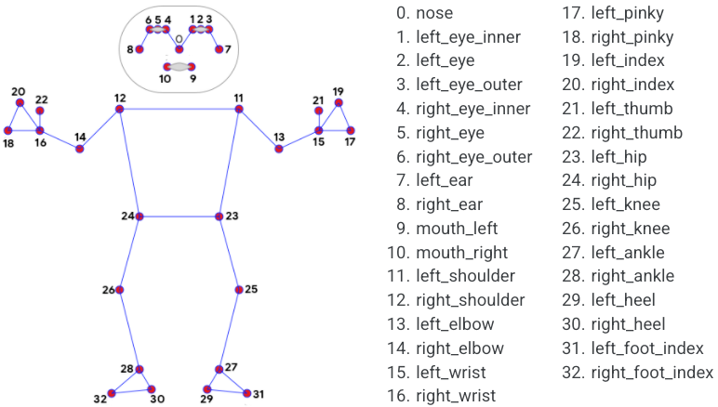

Pose estimation is a computer vision task that infers the pose of a person or object in an image or video. Pose estimation is the problem of determining the position and orientation of a camera relative to a given person or object. This is typically done by identifying, locating, and tracking a number of keypoints on a given object or person. For objects, this could be corners or other significant features. And for humans, these keypoints represent major joints like an elbow or knee. The goal of our machine learning models are to track these keypoints in images and video.

**Classification Algorithm: Multinomial** **Logistic Regression:**

Multinomial logistic regression is used to predict categorical placement in or the probability of category membership on a dependent variable based on multiple independent variables. The independent variables can be either dichotomous (i.e., binary) or continuous (i.e., interval or ratio in scale). Multinomial logistic regression is a simple extension of binary logistic regression that allows for more than two categories of the dependent or outcome variable.

Mathematically, a logistic regression model predicts P(Y=1) as a function of X.

Logistic regression models the data using the sigmoid function.

$f\left(x\right)=\frac{1}{1+e^{-(x)} }$**…(Eq.1)**

Multinominal Logistic Regression :

**…(Eq.2)**

# LITERATURE SURVEY

## 2.1 STUDY OF RESEARCH PAPERS

There are several surveys in the human activity recognition literature.

Gavrila (1999) separated the research in 2D (with and without explicit shape models) and 3D approaches. In Aggarwal and Cai (1999), a new taxonomy was presented focusing on human motion analysis, tracking from single view and multiview cameras, and recognition of human activities. Similar in spirit to the previous taxonomy, Wang et al. (2003) proposed a hierarchical action categorization hierarchy. The survey of Moeslund et al. (2006) mainly focused on pose-based action recognition methods and proposed a fourfold taxonomy, including initialization of human motion, tracking, pose estimation, and recognition methods.

A fine separation between the meanings of “action” and “activity” was proposed by Turaga et al. (2008), where the activity recognition methods were categorized according to their degree of activity complexity. Poppe (2010) characterized human activity recognition methods into two main categories, describing them as “top-down” and “bottom-up.” On the other hand, Aggarwal and Ryoo (2011) presented a tree-structured taxonomy, where the human activity recognition methods were categorized into two big sub-categories, the “single layer” approaches and the “hierarchical” approaches, each of which have several layers of categorization.

Modeling 3D data is also a new trend, and it was extensively studied by Chen et al. (2013b) and Ye et al. (2013). As the human body consists of limbs connected with joints, one can model these parts using stronger features, which are obtained from depth cameras, and create a 3D representation of the human body, which is more informative than the analysis of 2D activities carried out in the image plane. Aggarwal and Xia (2014) recently presented a categorization of human activity recognition methods from 3D stereo and motion capture systems with the main focus on methods that exploit 3D depth data. To this end, Microsoft Kinect has played a significant role in motion capture of articulated body skeletons using depth sensors.

Although much research has been focused on human activity recognition systems from video sequences, human activity recognition from static images remains an open and very challenging task. Most of the studies of human activity recognition are associated with facial expression recognition and/or pose estimation techniques. Guo and Lai (2014) summarized all the methods for human activity recognition from still images and categorized them into two big categories according to the level of abstraction and the type of features each method uses.

Jaimes and Sebe (2007) proposed a survey for multimodal human computer interaction focusing on affective interaction methods from poses, facial expressions, and speech. Pantic and Rothkrantz (2003) performed a complete study in human affective state recognition methods that incorporate non-verbal multimodal cues, such as facial and vocal expressions. Pantic et al. (2006) studied several state-of-the-art methods of human behavior recognition including affective and social cues and covered many open computational problems and how they can be efficiently incorporated into a human-computer interaction system.

Zeng et al. (2009) presented a review of state-of-the-art affective recognition methods that use visual and audio cues for recognizing spontaneous affective states and provided a list of related datasets for human affective expression recognition. Bousmalis et al. (2013a) proposed an analysis of non-verbal multimodal (i.e., visual and auditory cues) behavior recognition methods and datasets for spontaneous agreements and disagreements. Such social attributes may play an important role in analyzing social behaviors, which are the key to social engagement. Finally, a thorough analysis of the ontologies for human behavior recognition from the viewpoint of data and knowledge representation was presented by Rodríguez et al. (2014).

# PROJECT PLANNING AND MANAGEMENT

## 3.1 SOFTWARE AND HARDWARE REQUIRENMENTS:

* **HARDWARE:**
  + - RAM : 8 GB

As we are using Machine Learning Algorithm and Various High Level Libraries Laptop.

* + - RAM minimum required is 8 GB. Hard Disk : 40 GB

Data Set of Video/Image is to be used hence minimum 40 GB Hard Disk memory is required.

* + - Processor : Intel i5 Processor
    - Operating System : Windows 10

Latest Operating System that supports all type of installation and development Environment

* **SOFTWARE:**
  + - Operating System: Windows 10
    - IDE: VS Code
    - Programming Language : Python
    - Framework : Django

## NON FUNCTIONAL REQUIREMENT:

* **Performance Requirements**

The performance of the functions and every module must be well. The overall performance of the software will enable the users to work efficiently. Performance of encryption of data should be fast. Performance of the providing virtual environment should be fast Safety Requirement. The application is designed in modules where errors can be detected and corrected easily. This makes it easier to install and update new functionality if required.

* **Safety Requirement**

The application is designed in modules where errors can be detected and fixed easily. This makes it easier to install and update new functionality if required.

* **Software Quality Attributes**

Our software has many quality attribute that are given below:-

* Adaptability: This software is adaptable by all users.
* Availability: This software is freely available to all users. The availability of the software is easy for everyone.
* Maintainability: After the deployment of the project if any error occurs then it can be easily maintained by the software developer.
* Reliability: The performance of the software is better which will increase the reliability of the Software.
* User Friendliness: Since, the software is a GUI application; the output generated is much user friendly in its behavior.
* Integrity: Integrity refers to the extent to which access to software or data by unauthorized persons can be controlled.
* Security: Users are authenticated using many security phases so reliable security is provided.
* Testability: The software will be tested considering all the

## PROCESS MODEL:

The process model used was **Agile Process model**. Software development approach was based on iterative development. The tasks were broken into smaller iterations; they did not have a long time planning. The project scope and requirements were laid down at the beginning of the development process.  Focus was on quick responses to change and continuous development.  An adaptive approach was used where there is no detailed planning and there is clarity on future tasks only in respect of what features need to be developed.

# SYSTEM ANALYSIS & DESIGN

## 4.1 SYSTEM ARCHITECTURE:

A system architecture diagram would be used to show the relationship between different components. Usually they are created for systems which include hardware and software and these are represented in the diagram to show the interaction between them. However, it can also be created for web applications. For a web application the system architecture design would include components such as, database, application server, web server, internet, browser etc. Not all of these have to be included in the diagram and there are other components that can be included.

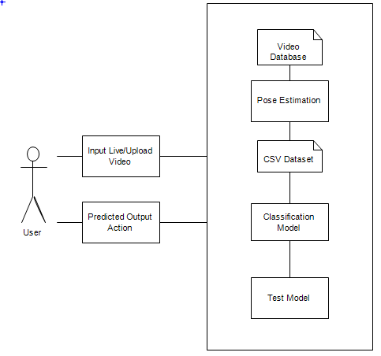

**Figure 4.1: System Architecture**

## 4.2 USE CASE DIAGRAM:

A use cases diagram at its simplest is a representation of a user's interaction with the system that shows the relationship between the user and the different use cases in which the user is involved. A use case diagram can identify the different types of users of a system and the different use cases and will often be accompanied by other types of diagrams as well. The use cases are represented by either circles or ellipses.

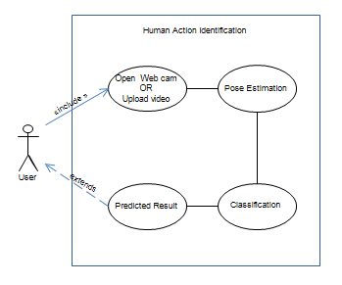

**Fig 4.2 Use case diagram**

## 4.3 CLASS DIAGRAM:

Class diagram is a static diagram. It represents the static view of an application. Class diagram is not only used for visualizing, describing, and documenting different aspects of a system but also for constructing executable code of the software application.

Class diagram shows a collection of classes, interfaces, associations, collaborations, and constraints. It is also known as a structural diagram.

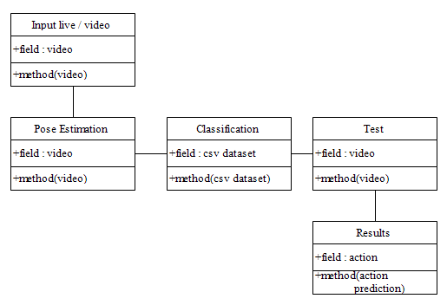

**Fig 4.3 Class diagram**

## 4.4 ACTIVITY DIAGRAM:

Activity diagram is basically a flowchart to represent the flow from one activity to another activity. The activity can be described as an operation of the system.

The control flow is drawn from one operation to another. This flow can be sequential, branched, or concurrent. Activity diagrams deal with all type of flow control by using different elements such as fork, join, etc.

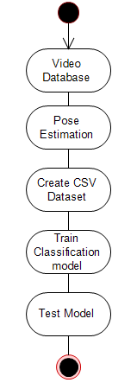

**Figure 4.4: Activity Diagram**

## 4.5 SEQUENCE DIAGRAM:

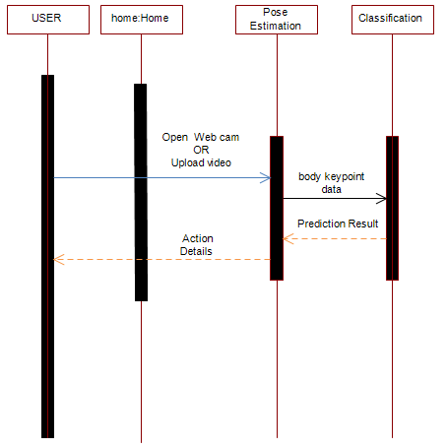

**Fig 4.5: Sequence Diagram**

## 4.5 DATA FLOW DIAGRAM:

In Data Flow Diagram, we Show that flow of data in our system in DFD0 we show that base DFD in which rectangle present input as well as output and circle show our system, In DFD1 we show actual input and actual output of system input of our system is text or image and output is rumor detected likewise in DFD 2 we present operation of user as well as admin.

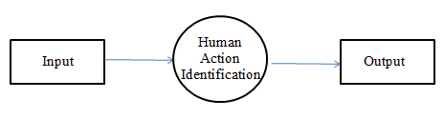

**Fig 4.5: Data Flow(0) diagram**

**Fig 4.6: Data Flow(1) diagram**

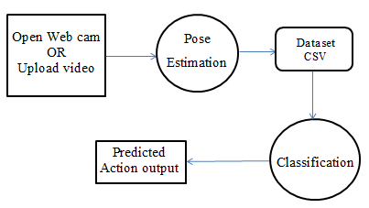

**Fig 4.7: Data Flow(2) diagram**

# SOFTWARE INFORMATION

Python**:** It is an interpreter, high-level and general-purpose programming language. Created by Guido van Rossum and first released in 1991, Python’s design philos- ophy emphasizes code readability with its notable use of significant whitespace. Its language constructs and object-oriented approach aim to help programmers write clear, logical code for small and large-scale projects.

Python is dynamically typed and garbage-collected. It supports multiple programming paradigms, including structured (particularly, procedural), object-oriented, and functional programming. Python is often described as a ”batteries included” language due to its comprehensive standard library.

Python was created in the late 1980s as a successor to the ABC language. Python 2.0, released in 2000, introduced features like list comprehensions and a garbage collection system with reference counting.

Python 3.0, released in 2008, was a major revision of the language that is not completely backward-compatible, and much Python 2 code does not run unmodified on Python 3.

The Python 2 language was officially discontinued in 2020 (first planned for 2015), and ”Python 2.7.18 is the last Python 2.7 release and therefore the last Python 2 release.”[30] No more security patches or other improvements will be released for it. With Python 2’s end-of-life, only Python 3.6.x and later are supported.

Python interpreters are available for many operating systems. A global com- munity of programmers develops and maintains Python, a free and open-source reference implementation. A non-profit organization, the Python Software Foundation, manages and directs resources for Python and Python development.

Anaconda**:** Anaconda is a free and open-source distribution of the Python and R programming languages for scientific computing (data science, machine learning applications, large-scale data processing, predictive analytics, etc.), that aims to simplify package management and deployment. The distribution includes data-science packages suitable for Windows, Linux, and macOS. It is developed and maintained by Anaconda, Inc., which was founded by Peter Wang and Travis Oliphant in 2012. As an Anaconda, Inc. product, it is also known as Anaconda Distribution or Anaconda Individual Edition, while other products from the company are Anaconda Team Edition and Anaconda Enterprise Edition, both of which are not free.

# PROJECT PLAN

In this chapter we are going to have an overview about how much time does it took to complete each task like- Preliminary Survey Introduction and Problem Statement, Literature Survey, Project Statement, Software Requirement and Specification, Sys- tem Design, Partial Report Submission, Architecture Design, Implementation, Deployment, Testing, Paper Publish, Report Submission and etcetera. This chapter also gives focus on stakeholder list which gives information about project type, customer of the proposed system, user and project member who developed the system.

## 6.1 SYSTEM IMPLEMENTATION PLAN

The System Implementation plan table, shows the overall schedule of tasks compilation and time duration required for each task.

|  |  |  |  |  |  |  |  |  |  |  |
| --- | --- | --- | --- | --- | --- | --- | --- | --- | --- | --- |
| Activities | Aug | Sep | Oct | Nov | Dec | Jan | Feb | Mar | April | May |
| Submission of project ideas. |  |  |  |  |  |  |  |  |  |  |
| Project Topic Discussion. |  |  |  |  |  |  |  |  |  |  |
| Approval of project idea. |  |  |  |  |  |  |  |  |  |  |
| First presentation about progress of project work(Review1 and Review2) |  |  |  |  |  |  |  |  |  |  |
| Submission of Stage1 report. |  |  |  |  |  |  |  |  |  |  |
| Start of implementation. |  |  |  |  |  |  |  |  |  |  |
| Presentation about progress of project work.(Review 5& Review 6) |  |  |  |  |  |  |  |  |  |  |
| Presentation about progress of project work.(Review 7& Review 8) |  |  |  |  |  |  |  |  |  |  |
| Submission of report for checking. |  |  |  |  |  |  |  |  |  |  |
| Final submission of report and project. |  |  |  |  |  |  |  |  |  |  |

# CONCLUSION

In this project we have introduced Human Activity Recognition technique which will detect the activity being performed in the input video/Image We have proposed a Human Activity Identification system based on pose estimation and convolutional neural network.

This system will combine the results of the 3D pose estimation model with the 1D convolutional neural network for better and more accurate detailed result generation

# REFERENCES

1. Aggarwal, J. K., & Cai, Q. (1999). Human motion analysis: A review. *Computer vision and image understanding*, *73*(3), 428-440.
2. Kamel, A., Sheng, B., Yang, P., Li, P., Shen, R., & Feng, D. D. (2018). Deep convolutional neural networks for human action recognition using depth maps and postures. *IEEE Transactions on Systems, Man, and Cybernetics: Systems*, *49*(9), 1806-1819.
3. Hossain, M. R. I., & Little, J. J. (2018). Exploiting temporal information for 3d human pose estimation. In *Proceedings of the European Conference on Computer Vision (ECCV)* (pp. 68-84).
4. H. P. S. A. Lateef and U. Eranna, "Modelling Approach to Select Potential Joints for Enhanced Action Identification of Human," 2018 International Conference on Electrical, Electronics, Communication, Computer, and Optimization Techniques (ICEECCOT), 2018, pp. 1506-1509, doi: 10.1109/ICEECCOT43722.2018.9001313.
5. R. A., Amiruzzaman, M., Ahmed, N., & Islam, M. R. (2020, August). Efficient Frequency Domain Feature Extraction Model using EPS and LDA for Human Activity Recognition. In *202020 3rd IEEE International Conference on Knowledge Innovation and Invention (ICKII)* (pp. 344-347). IEEE.
6. Gupta, Abhay, Kuldeep Gupta, Kshama Gupta, and Kapil Gupta. "Human Activity Recognition Using Pose Estimation and Machine Learning Algorithm."